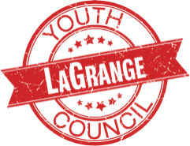

LAGRANGE YOUTH COUNCIL COMMITTEE CHAIR

Duties of a Committee Chair of the LaGrange Youth Council:
- Serve on select Youth Council committees in a leadership role.
- Help direct the committee towards a project that directly correlates to the issue adopted by the LaGrange Youth Council.
- With the support of LYC Advisors and Officers, help coordinate the main project of the committee.
- Utilize time outside of LYC as necessary in the said coordination.
- Aid in the promotion of the event to the general public (if public participation is part of the event).
(This position will act as lead coordinator for the committee’s main project and also help lead discussion during the committee breakout sessions.)

